**Bangladesh University of Professionals (BUP)**



**Faculty of Science and Technology**

**Department of Information & Communication Technology** (ICT)

**Web Technologies: ICE 3209**

**Assignment**

**Submitted By**

**Farah Farjana (18511067)**

**Section: B**

**Batch: BICE- 2021**

**Submitted To**

**Dr. Md. Shamim Al Mamun**

**Professor, IIT, JU**

**index.html CODE :**

<!DOCTYPE html>

<html>

<head>

    <title>Registration Form </title>

    <link rel="stylesheet" href="style.css">

    <style>

        #pdf-preview-container {

            display: flex;

            align-items: center;

            margin-top: 20px;

        }

        #pdf-preview {

            margin-left: 20px;

            border: 1px solid #ccc;

            box-shadow: 0 4px 8px rgba(0, 0, 0, 0.1);

        }

    </style>

</head>

<body>

    <div class="container">

        <h1>Registration Form</h1>

        <form action="action.php" method="post" enctype="multipart/form-data">

            <label for="name">Name:</label>

            <input type="text" id="name" name="name" required>

            <br>

            <label for="course">Course:</label>

            <input type="text" id="course" name="course" required>

            <br>

            <label for="phone">Phone:</label>

            <input type="text" id="phone" name="phone" required>

            <br>

            <label for="email">Email:</label>

            <input type="email" id="email" name="email" required>

            <br>

            <label for="address">Address:</label>

            <input type="text" id="address" name="address" required>

            <br>

            <label for="batch">Batch No:</label>

            <input type="text" id="batch" name="batch" required>

            <br>

            <label for="photo">Photo:</label>

            <input type="file" id="photo" name="photo" accept="image/*" required>

            <br>

            <label for="pdf">PDF File:</label>

            <input type="file" id="pdf" name="pdf" accept=".pdf" required>

            <br>

            <input type="submit" value="Submit">

        </form>

    </div>

</body>

</html>

**style.css CODE:**

/* CSS styles for the form */

body {

  font-family: Arial, sans-serif;

  background-color: #f5f5f5;

  margin: 0;

  padding: 0;

}

.container {

  max-width: 600px;

  margin: 0 auto;

  text-align: center; /* Center align the content */

  padding-top: 50px; /* Add top padding to move the heading down */

}

h1 {

  margin-bottom: 30px; /* Add bottom margin for spacing */

}

form {

  max-width: 400px;

  margin: 0 auto;

  padding: 20px;

  border: 1px solid #ccc;

  border-radius: 5px;

  background-color: #f9f9f9;

}

label {

  display: block;

  margin-bottom: 10px;

}

input[type="text"], input[type="email"], input[type="file"] {

  width: 100%;

  padding: 10px;

  margin-bottom: 15px;

  border: 1px solid #ccc;

  border-radius: 5px;

  box-sizing: border-box;

}

input[type="submit"] {

  width: 100%;

  padding: 10px;

  border: none;

  border-radius: 5px;

  background-color: #4CAF50;

  color: white;

  cursor: pointer;

}

input[type="submit"]:hover {

  background-color: #45a049;

}

/* id_card_style.css */

body {

  font-family: Arial, sans-serif;

  background-color: #f5f5f5;

  display: flex;

  justify-content: center;

  align-items: center;

  height: 100vh;

  margin: 0;

}

**action.php CODE:**

<?php

// Check if the form is submitted

if ($_SERVER["REQUEST_METHOD"] == "POST") {

    // Get the form data

    $name = $_POST["name"];

    $course = $_POST["course"];

    $phone = $_POST["phone"];

    $email = $_POST["email"];

    $address = $_POST["address"];

    $batch = $_POST["batch"];

    if (!file_exists('uploads')) {

        mkdir('uploads');

    }

    // Handle the uploaded photo

    $photo = $_FILES["photo"];

    $photoPath = "uploads/" . $photo["name"];

    move_uploaded_file($photo["tmp_name"], $photoPath);

    // Handle the uploaded PDF file

    $pdf = $_FILES["pdf"];

    $pdfPath = "uploads/" . $pdf["name"];

    move_uploaded_file($pdf["tmp_name"], $pdfPath);

    // Display the ID card information

    echo "<!DOCTYPE html>";

    echo "<html>";

    echo "<head>";

    echo "<title>ID Card</title>";

    echo "<link rel='stylesheet' type='text/css' href='id_card_style.css'>";

    echo "</head>";

    echo "<body>";

    echo "<div id='id-card-container'>";

    echo "<div id='id-card'>";

    echo "<img src='$photoPath' alt='Photo'>";

    echo "<div class='info'>";

    echo "<p><strong>Name:</strong> $name</p>";

    echo "<p><strong>Course:</strong> $course</p>";

    echo "<p><strong>Phone:</strong> $phone</p>";

    echo "<p><strong>Email:</strong> $email</p>";

    echo "<p><strong>Address:</strong> $address</p>";

    echo "<p><strong>Batch No:</strong> $batch</p>";

    echo "</div>";

    echo "</div>";

    echo "<div id='pdf-preview-container'>";

    echo "<button>Preview PDF</button>";

    echo "<div id='pdf-preview'>";

    echo "<object data='$pdfPath' type='application/pdf' width='500' height='600'></object>";

    echo "</div>";

    echo "</div>";

    echo "</div>";

    echo "</body>";

    echo "</html>";

}

?>

**id_card_style.css CODE :**

#id-card-container {

    display: flex;

    flex-direction: column;

    align-items: center;

}

#id-card {

    max-width: 400px;

    padding: 20px;

    border: 1px solid #ccc;

    border-radius: 10px;

    background-color: #fff;

    box-shadow: 0 4px 8px rgba(0, 0, 0, 0.1);

    display: flex; /* Display flex to position image and info side by side */

    margin-bottom: 20px;

}

#id-card img {

    width: 150px;

    height: 200px;

    border: 1px solid #000;

    border-radius: 5px;

    margin-right: 20px;

}

#id-card .info {

    display: flex; /* Display flex to align info vertically */

    flex-direction: column; /* Align info vertically */

    justify-content: center; /* Center info vertically */

}

#id-card .info p {

    margin: 0;

    line-height: 1.5;}

**OUTPUT:**

**First give input for all the information**

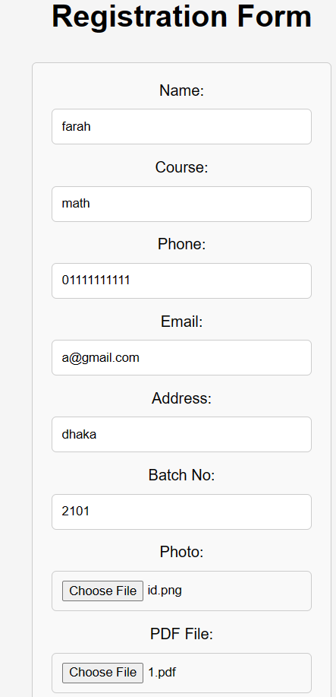

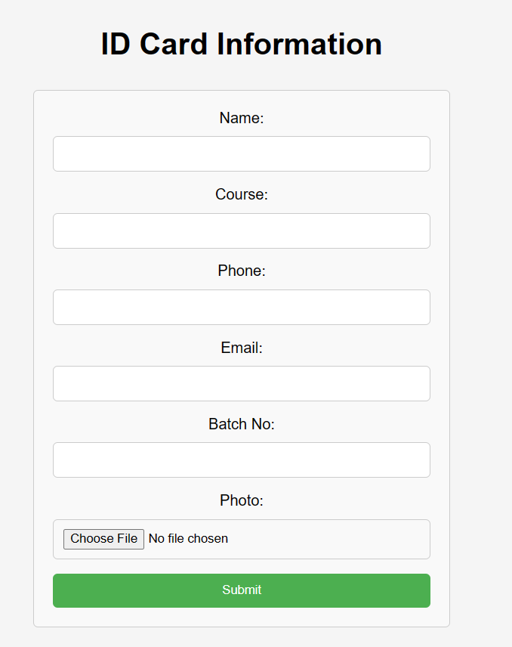

**All the options must be filled up.**

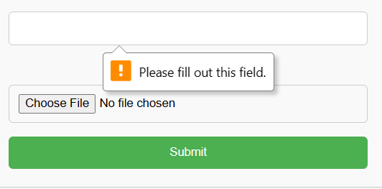

**Adding image from folder**

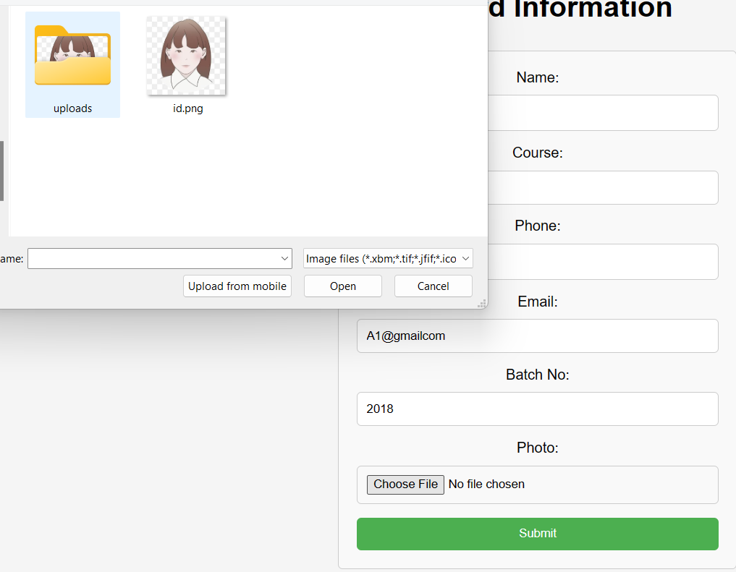

**It will change the status from “no file chosen” to the image file name “id.png”**



**Choose the file to be uploaded**

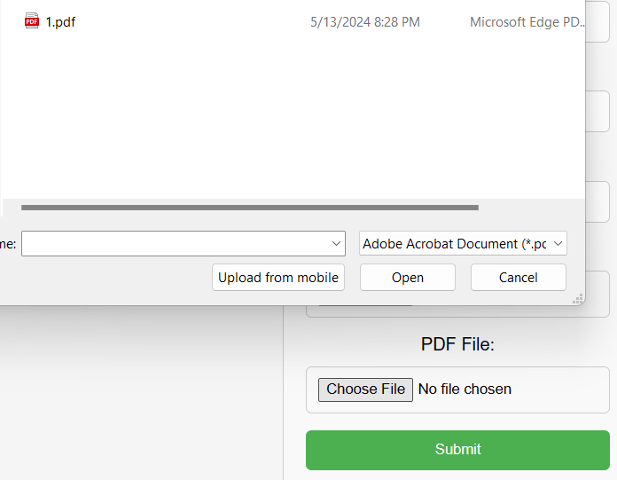

**After submitting the id card will be formed where the information is on the right side of the image by using div tag.**

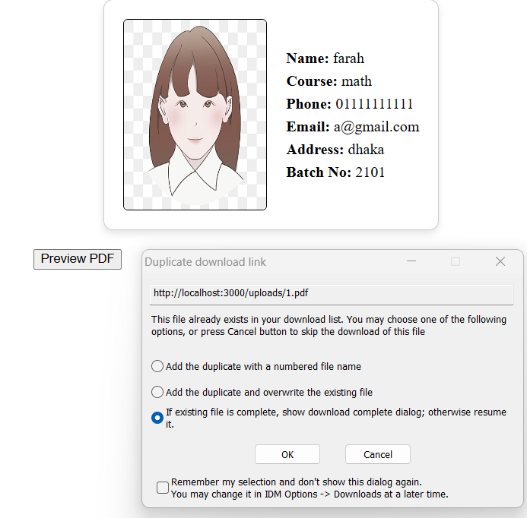

**And it will ask the user to download the file. The downloaded file will be in the downloads folder of the user.**

